Contents
Table of Contents 2
Eligibility and Enrollment 3
Medical Costs & Medical Plan Information 4
Wellness Information 5
Dental Costs with Plan Information 6
Vision Costs with Plan Information 7
Basic Life and Optional Employee/Dependent Life 8
Optional Employee/Dependent Life Cost Chart 9
Supplemental Insurance 10
Disability Plan Information 11
Contact and Website Information………………………………12

The information in this Enrollment Guide is presented for illustrative purposes and is based on information provided by the employer. The text contained in this Guide was taken from various summary plan descriptions and benefit information. While every effort was taken to accurately report your benfeits, discrepencies, or errors are always possbile. In case of discrepency between the Guide and the actual plan documents, the actual plan documents will prevail. The plan documents will govern all plans covered in this Guide. The Guide is not a contract or a guarantee of your eligibility or benefit. All information is confidential, pursuant to the Health Insurance Portability and Accountability Act of 1996. If you have any quesitons about your Guide, contact your firm administrator. If you sign up for coverage that requires evidence of insurability, even though deductions may start, you are not considered enrolled in the plans until confirmed by the carrier. If declined, you will be reimbursed. You can access benefit information at the following link: http://clarkebenefits.com/

It’s that time of year again! OPEN ENROLLMENT! Below are some changes we want you to be aware of as well as some updated information regarding the Affordable Care Act (ACA).
- First and foremost, C&C has negotiated and worked hard with Blue Cross/Blue Shield to minimize cost changes to our plan. In an environment where annual costs continue to go up, we are pleased that we were able to minimize that impact.
- The one area we have no control over is the Affordable Care Act (ACA) which continues to impact the cost of Medical Insurance across our country and for each and every C&C employee.
- In 2015, you will have a $4.98 weekly deduction specifically used to pay a portion of the Tax and fees resulting from the ACA. These monies are not used to pay for your insurance coverage. C&C will pay the remainder of the ACA fees.
- Despite these added ACA costs, C&C is pleased to continue to provide Day One insurance coverage using PPO plans each of which contain co-pay features for both your doctor visits and prescriptions.
As you consider your healthcare options, please remember two things:
- If you enroll in any of the Medical plans offered by C&C, you will meet the current ACA Individual Mandate and will not be subject to IRS penalties.
- You will not be eligible for any premium subsidies offered in the marketplace. As a full time employee, C&C already subsidizes your cost of medical insurance and meets the affordability requirement of the employer mandate under ACA.
This benefit enrollment period is your opportunity to choose the benefits that are best for you and your lifestyle. This guide has been prepared with all the information you need to select your 2015 benefit coverages.

WHEN TO ENROLL
Open Enrollment begins January 12th through January 23rd, during this open enrollment period you must complete the enrollment elections via our online web portal. If you do not complete online enrollment elections you could have an interruption in insurance coverage. After open enrollment, which concludes on 1/23/2015, to make any changes you will have to have a qualifying change in status. Qualified changes in status include: marriage, divorce, legal separation, birth or adoption of a child, change in child’s dependent status, death of spouse, child or other qualified dependent, change in residence due to an employment transfer, commencement or termination of adoption proceedings, or change in spouse’s employment status.

WHO IS ELIGIBLE
If you are a C&C regular full-time employee, you are eligible for benefits. Employees who work over 30 hours a week and are not temporary are considered full time employees. You are also eligible to cover your family members in the medical, dental, vision, and voluntary life insurance through C& C employer sponsored benefit plans
HOW TO ENROLL
The first step is to review your current benefit elections by logging into the open enrollment online web portal. Your current coverage’s, end on January 31st 2015. New Coverage begins on February 1st, 2015. Our carriers will continue to be BlueCross BlueShield of SC, Met Life, AUL, and EyeMed.

2015 COSTS OF COVERAGE
Medical Benefits
 | Weekly Deductions
 | Employee Only | Employee & Spouse | Employee & Children | Family
BCBS OF SC Core PPO Plan | $4.98 | $108.86 | $77.40 | $181.26
BCBS OF SC Basic PPO Plan | $20.60 | $139.32 | $103.09 | $222.91
BCBS OF SC Enhanced Plan | $52.27 | $208.18 | $161.14 | $317.04

Blue Cross  Blue Shield of SC | Core PPO Plan | Basic PPO Plan | Enhanced PPO Plan
 | In Network Benefits
Primary Care Physician | $30 | $35 | $25
Specialist Physician | $40 | $45 | $35
Preventive Screenings  (Consult Policy)  Preventive Maximum | $30/40 to a max of $500 annually | $35/45 to a max of $500 annually | $25/35 to a max of $500 annually
Urgent Care | $30 | $35 | $25
Office Surgery | 100% after copay | 100% after copay | 100% after copay
Emergency Room | Deductible/Coinsurance | Deductible/Coinsurance | Deductible/Coinsurnace
Prescription Drugs | $10 Generic/$35 Preferred/$55 Non Preferred  Specialty Rx $100 | $10 Generic/$35 Preferred/$55 Non Preferred  Specialty Rx $100 | $10 Generic/$35 Preferred/$55 Non Preferred  Specialty Rx $100
 | Major Medical Benefits
Deductible | $5000 (2x family) | $2000 (2x family) | $500 (2x family)
Max Out of Pocket | $5000 (2x family) | $5000 (2x family) | $3000 (2x family)
Coinsurance | 70% BCBS/30% Employee | 60% BCBS/40% Employee | 80% BCBS/20% Employee
Hospital  In and Out-Patient | IP: $200 copay/Deductible/Coins  OP: Deductible/Coins | IP: $200 copay/Deductible/coins  OP: Deductible/Coins | IP: Deductible/Coins  OP: Deductible/Coins
Lifetime Maximum | Unlimited | Unlimited | Unlimited
 | Out of Network Benefits
Deductible | $10,000 (2x family) | $4000 (2x family) | $1000 (2x family)
Max. Out of pocket | $10,000 (2x family) | $8000 (2x family) | $6000 (2x family)
Coinsurance | 50% BCBS/50% Employee | 50% BCBS/50% Employee | 50% BCBS/50% Employee
Lifetime maximum | Unlimited | Unlimited | Unlimited
We have three medical options to choose from. Our plan options include 3 traditional PPO plans. All three plans have co-pays for office visits/prescriptions, deductibles, and out-of-pocket maximums which must be met.
Medical insurance is an important part of your benefit package. Medical costs continue to rise at double-digit rates, and we must work together to control costs. You can help control costs by taking responsibility of your health by:
- Living a healthy lifestyle, exercise, eat a healthy diet, and take part in our health screenings and have an annual physical
- Identify health risks by taking the Personal Health Assessment (PHA)
- Be a wise health care consumer, take generic drugs when possible
- Take advantage of our wellness offerings
- Use preventive care services as much as possible
The BlueCross BlueShield of SC plan has co-pays, deductibles, coinsurance, and out of pocket maximums. The traditional PPO plans allows you to see any participating physician. BlueCross BlueShield of SC has a comprehensive network in your area. Please visit C&C University to learn about ways to manage your health care costs by gaining control of your personal health. http://clarkebenefits.com/cc-university password: cc01
Dental Benefits | Employee Weekly Deductions
 | Employee Only | Employee & Spouse | Employee & Children | Family
Dental Plan | $1.15 | $10.59 | $7.78 | $17.29

DENTAL
C&C offers employees and their families a comprehensive dental plan. Our dental plan is administered by Met Life. Our plan includes coverage for preventive, basic, and major dental services (see certificate for full coverage details). You may visit the dental provider of your choice but we also have a network available. Costs using a network provider are lower than a non-network provider. You can access the provider network by going to www.metlife.com and enter your zip code or your dentist’s name. You do not have to be the medical plan to have dental coverage. There are 4 tiers of coverage for you to choose from.

Met Life

 | In and Out of Network
 | Plan Benefits
Preventive | Pays 100% of costs (UCR)
Basic Services | 80%
Major Services | 50%
Deductible | $50/individual $150/family
Annual Maximum/Insured | $1,500
Orthodontia | Child Only (up to 19)
Orthodontia Services | 50%
Lifetime Ortho Maximum | $1,500

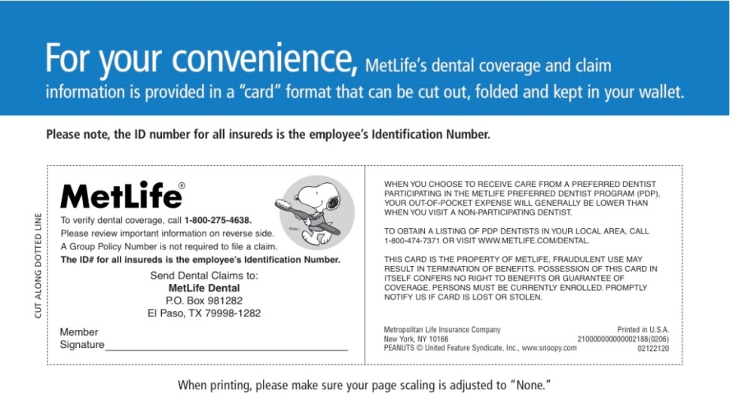
Vision Benefits | Employee Weekly Deductions
 | Employee Only | Employee & Spouse | Employee & Children | Family
Vision Plan | $0.94 | $1.82 | $1.92 | $2.82

EyeMed |  | In Network Benefits | Out of Network Benefits
Frames |  | Amount over $110 allowance | Up to $55 reimbursement
Contact Lenses |  | Amount over $110 allowance | Up to $88 reimbursement
Allowance Frequency: Eye Exams, Lenses, Contact Lenses, Frames |  | Annually | Annually
Standard Lenses |  | $0 | Up to $55 reimbursement
Material Copay |  | Varies by Lens Type | Not applicable
Other Lens Options |  | Copays range from $15 to $65 | Not Covered
Exam co-pay |  | $15 | Up to $35 reimbursement
Network |  | www.eyemedvisioncare.com  You will be using the Choice network
VISION
We are now offering employees and their families a comprehensive vision plan. Our vision plan is administered by EyeMed. Our plan includes an annual eye exam, $110 of material allowance, material co-pays and other discounts. You may visit the vision provider of your choice but we also have a network available consisting of retail stores such as Sears, Target, JC Penny Optical, Pearle Vision & other private practices. Costs using a network provider are lower than a non-network provider. You can access the provider network by going to www.eyemedvisioncare.com and entering your zip code in the provider search. Please choose the Choice plan when searching for a provider. You do not have to be on the medical plan to have vision coverage. There are 4 tiers of coverage for you to choose from. The additional information including an ID card will be on the last two pages of this enrollment guide.

LIFE INSURANCE & VOLUNTARY LIFE INSURANCE

AUL
Employees are provided with Group Basic Term Life in the amount of $25,000 per employee at no cost to you. Our coverage includes accidental death & dismemberment coverage. For accidental death our plan pays 100% of the life benefit (See the certificate of coverage for dismemberment benefits). Our coverage is convertible to you if you meet certain requirements*. You have 31 days from the date of termination to contact AUL to convert or port your coverage (see Human Resources for details). We also offer the ability to purchase additional amounts of coverage through payroll deductions. You can purchase coverage on yourself up to $100,000 guarantee issue, your spouse at $20,000 guarantee issue and your dependents at $10,000. This coverage is guarantee issue (no health questions asked) at initial enrollment after your date of hire. If you wish to pick up coverage at a later date you will be subject to evidence of insurability (required to fill out a health questionnaire).

Voluntary Life Insurance Employee Weekly Deductions
Age | 25k | 50k | 75K | 100K
<34 | .75 | 1.50 | 2.25 | 3.00
35-39 | .92 | 1.84 | 2.76 | 3.68
40-44 | 1.15 | 2.30 | 3.45 | 4.60
45-49 | 1.73 | 3.46 | 5.19 | 6.92
50-54 | 2.71 | 5.42 | 8.13 | 10.84
55-59 | 4.62 | 9.23 | 13.85 | 18.46
60-64 | 6.35 | 12.70 | 19.05 | 25.40
65-69 | 10.44 | 20.88 | 31.32 | 41.76

Voluntary Spouse & Dependent Life Insurance Employee weekly Deductions
Option 1 |  |  |  | Option 2 |  |  |  |  | Option 3
 | Coverage |  | Per Pay Period |  | Coverage |  |  | Per Pay Period |  | Coverage | Per Pay Period
Spouse | $5000 |  | .51 |  | $10,000 |  |  | 1.02 |  | $20,000 | 2.05
Child(ren) | $2500 | .20 |  |  |  | $5000 | .39 |  |  | $10,000 | .79
Family | See Above | .71 |  |  |  | See Above | 1.42 |  |  | See Above | 2.84
Minimum Employee Life | $25,000 | See Age Bands |  |  |  | $25,000 | See Age Bands |  |  | $50,000 | See Age Bands

Unum Supplemental Insurance
Unum offers Supplemental Coverage to all employees. The supplemental policies that can be purchased are:
- Accident Insurance (which concludes a hospital confinement rider)
- Critical illness with cancer insurance. This does include a health screening benefit.
- Whole Life Insurance is also available. Dependent coverage is also available to be purchased.
- You have two options to enroll, there will be a link on the EmpowHR website to direct you to the Unum enrollment platform or you can call 1-800-416-3851 starting January 12th-23rd during the hours of 8AM-8PM.

DISABILITY INSURANCE
C&C provides employees the opportunity to purchase Long Term and Short Term Disability plans. Your Long Term plan covers you up to 60% of your income to a maximum of $5,000 per month. The Long Term plan could cover you to Social Security Normal Retirement Age. Your Short Term plan covers you up to 60% of your income to a maximum of $1000 per week with a 11 week benefit. period..

Long-Term Disability | AUL
 | Plan Benefits
Monthly Benefit Max | $5000
Income Replaced | 60%
Elimination Period | 90 days
Partial Disability Paid | Yes
Benefit Payable | To SSNRA*

Short-Term Disability | AUL
 | Plan Benefits
Weekly Benefit Max | $1000
Income Replaced | 60%
Elimination Period | 15 day accident/15 days sickness
Partial Disability Paid | Yes
Benefit Payable | 11 weeks

CONTACT INFORMATION AND RESOURCES
Clarke and Company Benefits Contact Information
Columbia: 803-253-6997
All Other Locations: 888-540-9403
Edwin Croft, Client Manager: ecroft@clarkebenefits.com
Laura Howell, Account Manager: lhowell@clarkebenefits.com
Bradley Poole, Customer Service Rep: bpoole@clarkebenefits.com

Clarke and Company Benefits Resources:
C&C University: http://clarkebenefits.com/cc-universityPassword: cc01
Employee Model Notices: http://clarkebenefits.com/-health-care /

BlueCross BlueShield of SC:
Website: www.southcarolinablues.com Here you can find an in-network provider, manage claims, take your health risk assessment and much more.

EyeMed:
Website: www.eyemedvisioncare.com
-Click “Find a provider” on the top left side of the home page. Choose Choice as your network option, and then enter your desired zip code.
Find benefit summaries, network info, certificates of coverage and much more.
Met Life:
Website: www.metlife.com Click “Find a dentist” on the right hand side of the page to find a provider near you.

